Development of the Cajun Culture
William Bartholomew
GEOG 4505

What is an ethnic group? By most official definition an ethnic group, or ethnicity, is a socially defined category of people who identify with each other through shared ancestral, social or cultural traits. Ethnic groups exist all over the world and can range in size from being large enough to fill an entire country or limited to only one specific region within the entire world. Some ethnic groups tend to remain misunderstood or relatively unknown, but other have gained so much attention that they have become a defining feature of the location they are based in and even spread their names to places outside their homeland. A prominent example of one of these ethnic groups is the Cajun people who are based within the state of Louisiana within the southeastern United States of America. Whether it is from an actual visit to Louisiana or from a bottle of seasoning labeled “Cajun Style”, many people within the United States are familiar with the name of this ethnic group; some people are unable to even think of Louisiana without the Cajun culture coming to mind. However, like many unique ethnic groups, most people outside the immediate region know little to nothing about the actual origins and practices of the Cajun people. How did the Cajun ethnic group come to be, how have they developed over time to become a prominent symbol of Louisiana culture? These are the questions that I will attempt to answer in this research paper.
The people who would go on to develop the Cajun culture started out as French settlers traveling to North America during the 17th and 18th centuries. During this time of European settlement within North America, French territory was concentrated mostly within eastern Canada and what would go on to be the American Midwest one day. However, a majority of these settlers immigrated to Nova Scotia, Prince Edward Island and New Brunswick. These settlers established a number of communities around the Bay of Fundy, which became known as Acadia, a French colony that would thrive within this location for over a century (Mayda, 2013). In 1754, the French and British began to fight over the potential profit North America held, especially within the fishing and fur trades, which resulted in a large conflict known as the Seven Years’ War, the North American theater of which was known as the French and Indian War, which encompassed a majority of New England and Eastern Canada (including Acadia). The war ended in France’s defeat with the Treaty of Paris being signed in 1763, and as a term of the treaty, France had to forfeit its rights to the territory they had claimed within North America. Soon after Britain gained the rights to Acadia and the surrounding region, problems began to arise. Tensions formed between the prominently Catholic Acadians and the prominently Protestant English and Acadia was very uncooperative with British rule, refusing to take part in most forms of business with Britain or locations related to it. This led to a mass exodus of the French population of Acadia between 1755 and 1763, and thousands of Acadians were forced from their homes to settle elsewhere (Mayda, 2013). Most of them settled in various British American colonies or places within the Caribbean, but others decided to move back to France and others still decided to move to the Spanish colony of Louisiana.
The semi-tropical climate of Louisiana proved to be difficult for the Acadians and many died from disease, but they managed to establish themselves within the region and more Acadians eventually joined their brethren to settle within southern Louisiana. They cultivated the land for agriculture, fished the Gulf of Mexico and surrounding bayous, and navigated the Mississippi river. Multiple interactions with other groups of people living within Louisiana at this time, such as the Spanish, Native Americans, and French Creoles to name a few, eventually led to the Acadians changing into what is now known as the Cajun culture (Mayda, 2013). The actual name for the people of this new culture, “Cajun”, is an evolution of the word “Acadian” in the French-based creole language that was widely spoken among the residents of the Atchafalaya Basin. After the Louisiana Purchase of 1803 with France, Louisiana became a territory of the United States and Americans began to settle within the area seeking profit. The Cajuns sold fertile land along the Mississippi to these emigrants while they themselves moved west to what is now south-central Louisiana, around the region of the Atchafalaya Basin (Figure 2) (Mayda, 2013). The region became known as Acadiana due to the Cajun origins within the Acadians. The Cajuns became proficient in hunting, trapping and fishing in order to adapt to the new environment they found themselves in. Various animal species, such as alligators and muskrats, were captured for use as sustenance or as trade items with other people, namely their skins and meat. Agriculture was another fairly important part of the Cajun culture at the time, as they grew crops such as cotton and rice, though due to the inability of the swamps to support these crops, they were grown in other nearby environments with more favorable conditions for agriculture. (Mayda, 2013). All of these factors created a strong basis upon which the Cajun culture could develop, but even with this strong basis the Cajun culture experienced its share of difficulties
In the late 1800s, around the time that the Civil War had ended, a new label was given to the Cajuns as being “white trash” and they were considered by many to be uneducated as well as uncivilized. The resulting pressure from this discrimination prevented Cajuns from competing in most job markets and many of them were forced to move to new locations to find work, most of which ended up being employed as tenant farmers. In addition, an influx of English speaking American citizens shifted the balance of ethnic groups in Louisiana, resulting in a prominence of English speaking citizens within Louisiana by the time the 20th century came around. This shift caused a rift between the white Creoles of New Orleans and the Cajun French, but due to the newly established prominence of the white Creole population, they were able to gain significant influence over the future of the Cajun culture and one area they began with was language. The isolated lifestyle that the Cajuns had lived during their early years allowed for the development of their own version of the French language which would go on to be labeled “Cajun French”. However, as the influence of the English speaking white Creoles grew, many Cajun children who attended schools in New Orleans were forced to learn and speak English and were discouraged from speaking their native Cajun French, which set the stage for a period in time where Cajun culture and language were almost wiped out (Mayda, 2013). In a 2014 online survey done by an academic journal, a number of students within the region of Acadiana were examined on how they perceived the accents of people speaking Cajun English, Standard American English and Southern English; the accents were judged based on two dimensions of perception: solidarity (social closeness) and competence (education and intelligence). The results showed that Cajun English is rated significantly higher than Standard American English and Southern English in terms of solidarity as opposed to Standard American and Southern English being rated higher in terms of competence. This may suggest a strong impact of the forced English teaching in Acadiana schools, as it seemed to make local inhabitants feel as if their own way of life was not to be associated as much with education and intelligence (Kroll, 2014).
Sometime during the 20th century, the entirety of the French Louisiana cultural regions and local cultures were all given the label of “Cajun” or “Acadian” even though various people within these groups did not have any Acadian ancestry. Several factors came into play around this time that sought to pull the Cajun culture out of its isolation and “Americanize” them. Examples of such factors include both World Wars drafting Cajun citizens into the army, the oil industry luring Cajuns to it with the promise of work, and even pressure from the Louisiana government to leave behind the French culture many Cajuns stuck to in favor of the American culture (Mattern, 1998). Around this time, it became imperative for the Cajun people to make efforts to preserving and revitalizing their culture. This was achieved through multiple methods but one of the most influential methods was the use of music. Cajun music would be played at folk festivals set up by applied folklorists and local activists in an effort to display the Cajun culture to the public outside of Acadiana; early examples of these festivals include the 1939 National Folk Festival in Dallas Texas and the 1964 Newport Folk Festival (Sexton, 2011). In addition to these festivals, Harry LeFleur established the Cajun French Music Association in 1984, which was created to preserve and promote traditional Cajun culture. The association contains chapters in Louisiana, Texas and Illinois and remains active in Cajun ethnic revival and cultural advocacy. However, there has been a clash of ideals between members of the Association and elderly Cajuns as to what it actually means to preserve the Cajun culture. The variation within the Cajun culture has made it difficult to determine what exactly counts as “traditional” practices and these disagreements can cause an issue of identity for the Cajun culture because if its own people can’t define the culture, how is anyone else supposed to? However, at the same time, the influence of the older generations of Cajuns and of the CFMA continues to diminish, opening the way for the new generations to both preserve the old traditions as best they can while acknowledging and incorporating the diversity of new musical styles into the Cajun culture (Sexton, 2011).
Nowadays the Cajun culture has become recognized as a major aspect of the state of Louisiana. The Department of Culture, Recreation, and Tourism have generalized the state into 5 particular regions, mainly based on the cultural and/or social attitudes prevalent within each region. One of these 5 regions is given the title of “Cajun Country” as it encompasses the boundaries of the Atchafalaya Basin where the Acadian culture originally settled in Louisiana and where the Cajun culture remains the most prevalent today (Figure 1). An interesting thing to note is that the word “Cajun” is used in multiple businesses throughout the state, but the majority is located in southern Louisiana. The only known CRT region that recognizes Cajun/Acadian heritage is the Cajun Country region, but interestingly enough, only about 17 of the aforementioned businesses can be found in this region and only one of those 17 can be found within the Cajun/Acadiana cultural region. This is a significant indication that the word “Cajun” holds more influence outside of its own cultural region and shows how the tourism industry has made use of it (McEwen 2014).
Due to 20th century developments in transportation and communication, the Cajun culture has been able to spread its influence even further than before. Various aspects of the Cajun culture, such as cuisine and music, have worked their way up to a high standing point within the “American ethnic mosaic” (Keul 2014) and are now quite widespread outside of the Atchafalaya Basin. This popularity leads to curiosity from people outside the region and in turn has made observations of the Cajun culture an integral part of Louisiana’s current tourist industry. Nowadays many stores within Louisiana sell various merchandise that carry a “Cajun” brand to it in order to enhance its distinctiveness and appeal to tourists, but Louisiana seems to shine through the most in its ability to give tourists a taste of “authentic” Cajun culture. Various dances, restaurants and music festivals are able to produce modern versions of particular Cajun narratives that greatly appeal to tourists.
Probably one of the most defining features of the Cajun culture is that of the swamp environment within the Atchafalaya Basin. Most Cajuns actually reside in urban environments today but this association with the swamp environment is understandable. The fact that a significant portion of southern Louisiana’s landscape is swampland and the Cajun ancestor’s settlement of that particular region has made the swamp environment a major symbol of the Cajun culture. The main reason for this universal association can be seen as an act of propagation by the tourism industry. One of the main qualities that make a specific ethnic group a good topic for tourism is the its uniqueness in comparison to other ethnic groups. Many people can find certain romanticism in a group of people living within a typically unwelcome environment to settlement and the unique practices that have developed from living in a location that is both different and isolated from most other settled regions within Louisiana. It is true that the Cajun culture made a living for itself within the swamp environment and isolation would come easier in the Atchafalaya Basin due to the size of the area within it (~5,700 km squared) and the difficulties inherent in navigating its wetlands. Both of these factors tended to discourage communications between the groups that lived within the basin’s limits and those who did not (Keul, 2014). In addition, the ancestors of the Cajun culture, the Acadians, maintained an ideal of subsistence hunting and agriculture where they hunted and farmed only what was needed. The isolation from most other cultures helped Cajuns inherit and maintain this mindset as they learned how to gather and grow what was needed from the swamp environment. These factors of isolation and specific practices are made even more unique by the fact that though the Cajun culture has spread to other places, it is still at its strongest within the within Louisiana and within the Basin. This presents a very specific location, which emphasizes an importance of “place” not only for the Cajun culture but also aids in the stories spread by the tourism industry (Keul 2014).
By the time the 1870s rolled around, the Cajun culture had become significantly less dependent on the swamp. Nowadays most people living within the Atchafalaya Basin depend on national and global markets to promote their economy by selling their labor and products. However, both the state of Louisiana and tourism professionals still give tourists the idea that the Cajun culture is fairly dependent on the swamp for sustenance and other basic needs. It is in this manner that the tourism industry has created “a heritage ecology” for the Cajuns, where the tourism industry talks up the aspects of the Cajun culture that are more intriguing to tourists (i.e. living off the swamp, long-time isolation, etc.) but at the same time ignoring the more modernized and commonplace aspects of the culture. In addition, as stated above, the CRT has made a significant portion of southwest Louisiana into a distinct region known as Cajun Country. While there is no denying that Cajun people reside in this region, there is a problem with the government officially labeling regions to the eyes of the public both inside and outside the state. A significant portion of Cajun Country intersects with another well-known region called Acadiana. Through the government giving the region a more “official” label, the region of Acadiana loses a spot on the map and is no longer recognized for its Creole heritage and identity, which is a historically separate culture from the Cajun culture that also inhabits the region. Though this “heritage ecology” has given people a misrepresentative view of the current Cajun culture, it has promoted tourism in the Atchafalaya Basin, and while this practice is not quite “environmentally-friendly” it does promote the economy of both the basin and Louisiana as a whole (Keul, 2014).
The history and practices of many ethnic groups throughout the world remain an unknown factor to many people outside the influence of that specific group. The Cajun culture is an excellent example of cultural diffusion, considering that it is the result of the Acadian cultures interactions and shared thoughts with multiple other people as well as their adaptions to the new environment they settled in. In addition they have given a ‘personality’ to the Atchafalaya Basin making it a more distinctive place within Louisiana and leading to a promotion in the unique swamp tourism. Like many other ethnic groups the Cajun culture has had to go through many trials to not only develop its culture but also preserve it. Despite the many challenges that the Cajun culture has faced, it has become a prevalent part of the cultural mosaic of Louisiana and the U.S. as a whole. The Cajun culture still faces issues of identity today and continued pressure from tourist expectations may lead to the loss or gain of additional cultural features. However, this will always be a part of life for people within a culture; they will struggle to preserve what is theirs and come to adapt new ideas along the way.

Works Cited
Keul, A. 2014. Reliving off The Swamp: A Cajun Tourism Commodity. Geographical Review 104 (4): 506-522
McEwen, J. 2014. Louisiana: Apprehending a Complex Web of Vernacular Regional Geography. Southeastern Geographer 54 (1): 55-71
Mayda C. 2013. A Regional Geography of The United States and Canada. Lanham, MD: Rowan and Littlefield Publishing Group Inc.
Kroll T. 2014. Acadiana-Area Speech-Language Pathology Students’ Perceptions of Cajun English Speakers. Contemporary Issues in Communication Science & Disorders 41: 210-220
Sexton, R. 2011. Too Loud, Too Wild? Negotiating Cajun Cultural Representations. Ethnology 50 (2): 117-134
Mattern, M.1998. Cajun music, cultural revival: Theorizing political action in popular music. Popular Music & Society 22 (2): 31-48

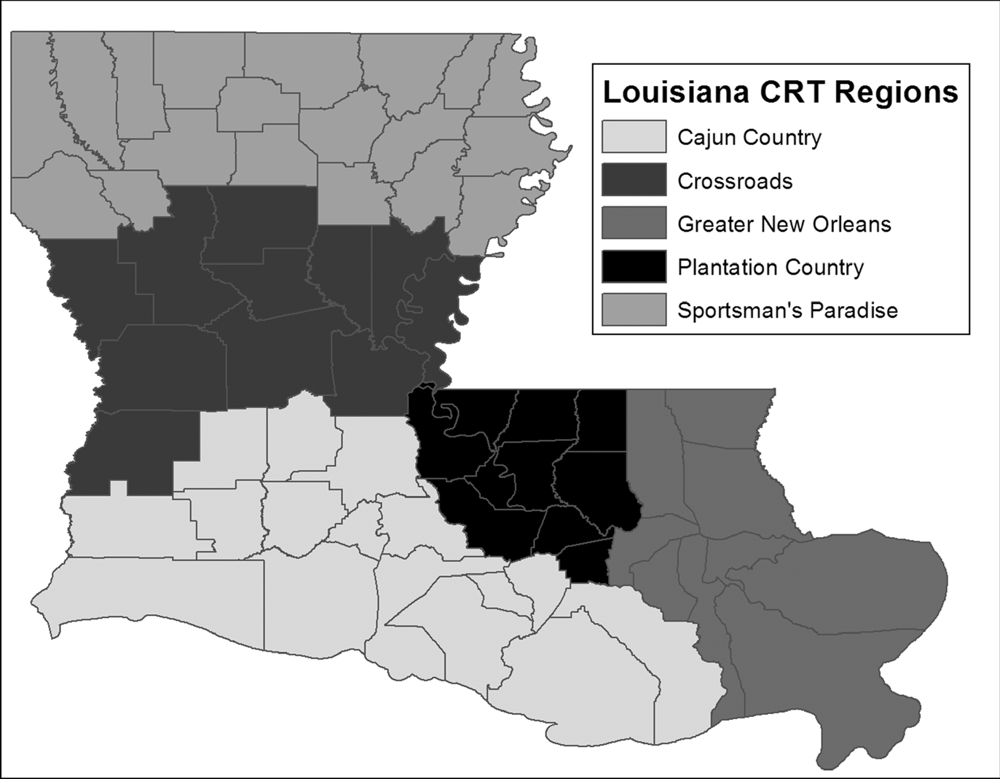

(Figure 1, Regions of Louisiana as published by the CRT)

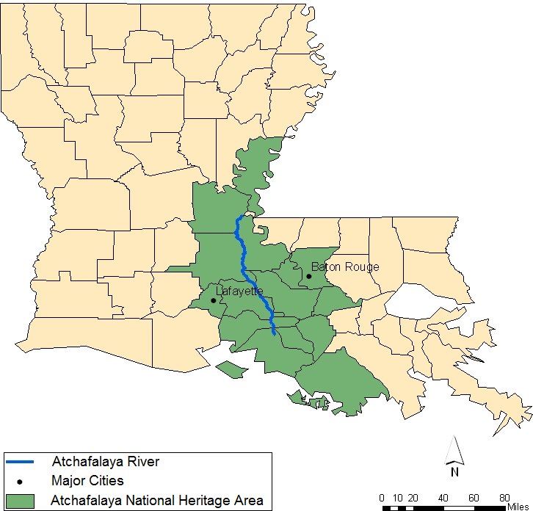

(Figure 2, Map of the Atchafalaya River Basin area)

