Analyzing the Cultural and Political Catalysts of the Rohingya Status within Southeast Asia

By

William Bartholomew

A Senior Thesis Submitted to the Faculty
of the Department of History and Geography
Georgia College State University
in Partial Fulfillment of the Requirements
for the Degree Bachelor of Arts

Milledgeville GA
May 2016

Introduction
One of the defining characteristics of a state is that a permanent resident population must be present within the territory that is claimed by the state. The people who make up this residence, however, do not necessarily have to co-exist peacefully with one another. One of the main ways that sharing residence with someone can become strained is through centrifugal forces dividing the people living in the same location. Diversity is an aspect of humanity that is highly encouraged in this day and age. Many locations such as the United States of America and many parts of Europe have accepted migrants into their states and have become veritable melting pots as a result. The most prominent example of encouraging diversity can be seen in Indonesia, whose very motto is unity through diversity. Differences within a population can lead to new ideas and views towards the world, but it can also be the catalyst for division within a population. Although many people can come to accept the fact that some people are different from them, there will always be a select few people who believe their way of life to be correct, and will retaliate viciously against anyone who differs. Identity has always been an important factor to people around the world. Although most people are able to identify themselves within their own ethnic group, it is something entirely different to be given an identity by the government of a country. In order to deny the rights and identity of an unwanted group of people, the government of a country may go so far as to deny them any identity and by extension deny them any rights as a citizen of the country. A prominent ongoing example of this denied identity within a country can be seen with the Rohingya minority of Burma. Therefore, the purpose of this paper will be to analyze the historical, political, cultural and geographic elements inherent in this situation where the country of Burma has denied the Rohingya their basic civil rights.
Literature Review
As stated above, one of the main driving forces behind the Rohingya’s current situation is the Burmese political structure. A 2014 report by the International Crisis Group (ICG) provided significant information on the current situation within Burma. The ICG is an international non-profit, non-governmental organization that works to prevent deadly conflicts worldwide. While the report was not specifically aimed at the Rohingyas, it did go into detail about the political situation within the Rakhine state of Burma, the location where the majority of the Rohingya population resides. It addressed the history of Rakhine in relation to both the population patterns and politics of the state. In addition, it outlined the mechanics of the laws that prevent the Rohingyas from being able to have the most basic of civil liberties. The report also addressed the viewpoints of both the Muslim and Buddhist populations of the state. It also offered ideas toward resolving the current situation within Rakhine. Another ICG (2013) report specifically addressed the discrimination and violence against the Muslim population within Burma. It provided a brief history of this violence, calling specific attention to the Rakhine Riots of 2012. In addition, it went into detail on the effects of these riots in continuing to encourage violence against the Rohingya and other Muslims within Burma. Furthermore, it called attention to violence against Muslims in other places besides the Rakhine state, although some of the most extreme cases of violence against Muslims take place within Rakhine.
Considering the scale of marginalization of the Rohingya people, it has become an engaging topic to many researchers attempting to study and address the situation. A 2014 news article released by the United Nations High Commissioner for Refugees (UNHCR) went into detail about the increasing reports it was receiving regarding the abuse and exploitation of the Rohingya people. These reports were mainly from countries outside of Burma due to a large number of Rohingyas fleeing Burma in order to escape the poor conditions and abuse they have to live with. The UNHCR is an agency of the United Nations that focuses on providing aid to refugees, particularly in repatriation. As such, the situation with the Rohingya is a matter of utmost importance to the UNHCR, which has been attempting to provide aid to Rohingyas all throughout Southeast Asia. In addition, a 2015 report by the United States Holocaust Memorial Museum (USHMM) went into extensive detail on the current poor living arrangements of the Rohingya within Burma. It also described Rohingya’s lack of rights and the hate speech that continued to be given against them by Buddhist nationalists.
Another important characteristic of the Rohingya is their status as refugees in other Southeast Asian countries. Castles et al (2014) covered migration within Asia, including some useful points that provided perspective on the Rohingya refugee situation within Southeast Asia. It discussed migration from a historical, political, and economical perspective, and acknowledged that migration is a spatial concept and, by extension, a geographical one. They addressed the push-pull factors of migration that were used to explain how various factors cause people to leave a location and migrate to a new one. The theory is not taken as seriously today due to its lack of specification as to the role of these factors and the interactions both take to result in migration. According to Castle (2014),
The disadvantage with the push-pull model is that it is never entirely clear how the various factors combine together to cause population movement. We are left with a list of factors, all of which can clearly contribute to migration, but which lack a framework to bring them together in an explanatory system…

The push-pull factor model was still acknowledged as an important thinking tool because it made people ponder on factors that would drive someone to migrate and to take all these factors into account in order to come up with a relationship between them that best explains migration patterns.
Setting
Before analyzing the Rohingya situation, it is important to understand the environment these people occupy. Burma, officially known as Myanmar, is a country located within the Malay Peninsula in Southeast Asia (see Figure 1). Speaking in terms of territorial morphology, Burma is defined as a prorupt state. It borders the Bay of Bengal and Andaman Sea to its west. In addition, it shares borders with Bangladesh, India, China, Laos and Thailand. The country has a total area of 676, 578 square kilometers, making it only slightly smaller than the area of Texas. Burma experiences a tropical monsoon climate, which is defined by a seasonal change in wind direction between the land and the ocean. During the summer, the winds blow in from the ocean to the land, which produces copious amounts of precipitation over the country. In the winter, the wind blows from the land to the ocean, which reduces the amount of precipitation within the country. Regardless of the season, the overall temperature within Burma changes very little, and despite having pronounced wet and dry seasons, the country can still receive 60 millimeters of rain during its driest months. Centralized lowlands that are surrounded by rugged highlands define the topography of Burma. While Burma does have several major urban areas such as its capital Rangoon, Mandalay, and Nay Pyi Taw, 48.2 percent of the country’s land is forested and only 19.2 percent is utilized for agricultural purposes. Like many other countries within Southeast Asia, Burma is a multinational state, compromised of people of varying languages, ethnicities, and religions. Of the 56 million people who live in Burma, the majority of its citizens identify themselves as Burman, but there are also Shan, Karen, Rakhine, Mon, and various other smaller ethnicities within the country (CIA 2016). Burmese is the official language
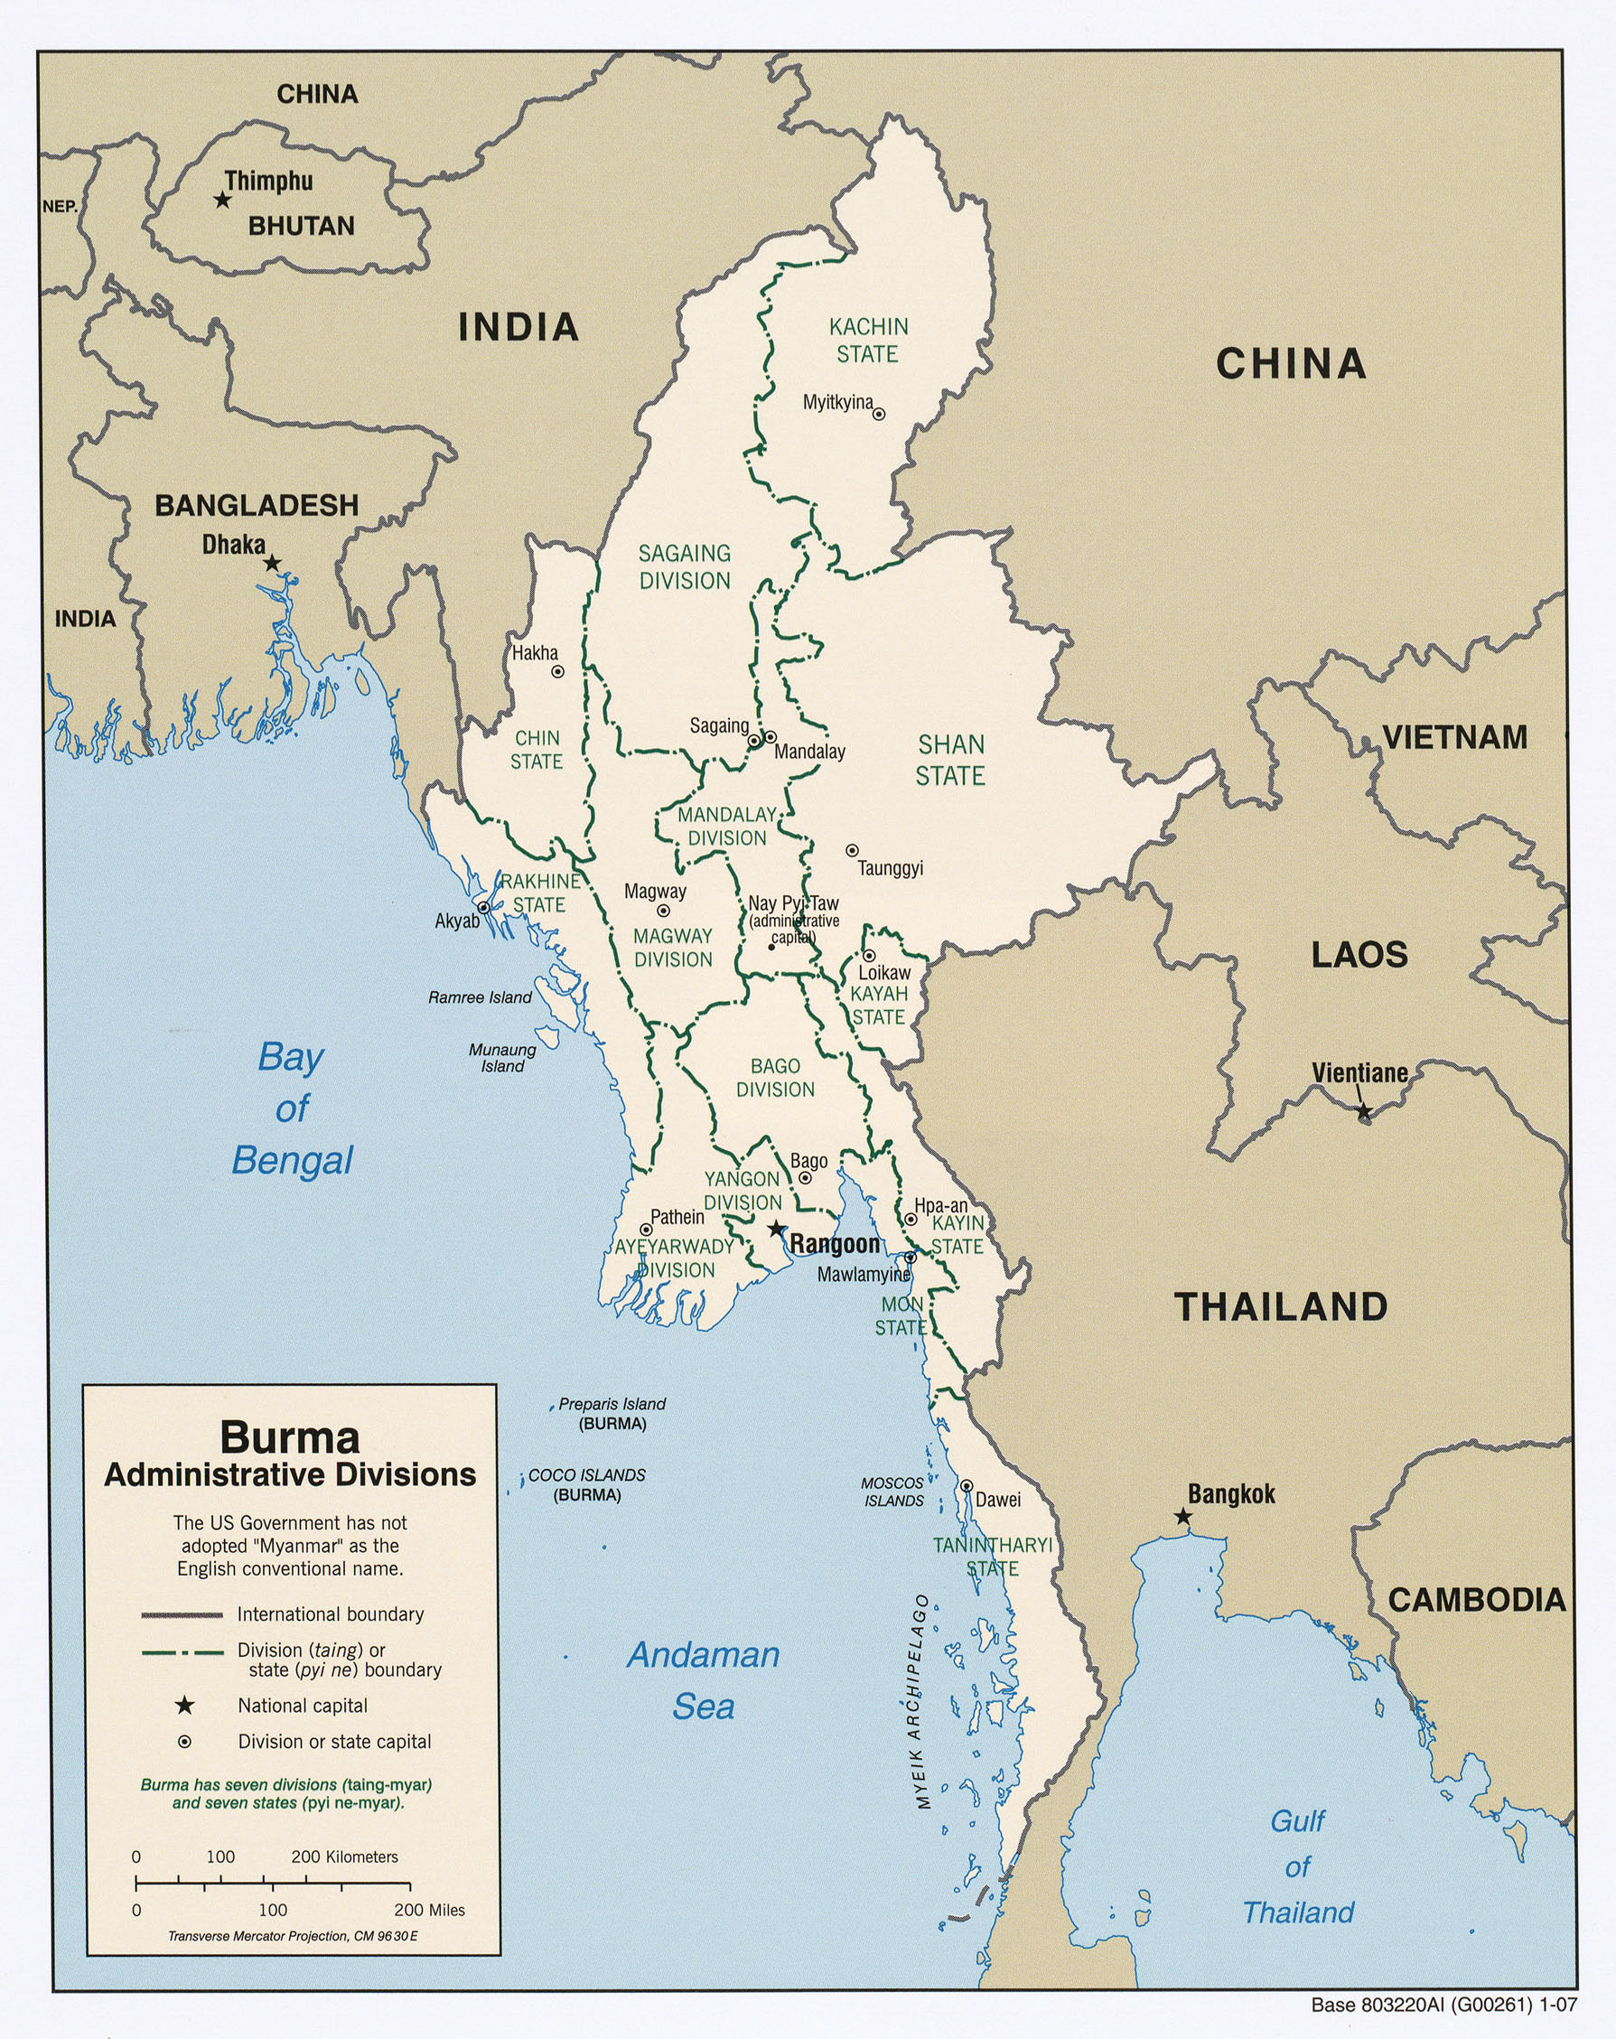
Figure 1: Map of Burma (ICG 2014)

of the country, however, there are multiple dialects of the language spoken throughout the various communities in Burma as well as other languages such as Bengali, Shan, and Mon (CIA 2016). There are eight established states within Burma. This paper focuses on the Rohingya population of the Rakhine state in western Burma, which borders southern Bangladesh (see Figure 2). Native Rakhine Burmans make up the majority of the population for this state, but several other minority groups, of which the Rohingya are an example, also define it. The term “Rohingya” is mainly used to identify Muslim people located in the former Mayu Frontier, which was located in western Burma near the Naf River and today is the state of Rakhine (Chan 2005). Charney (2005) noted that,
The earliest recorded use of an ethnonym immediately recognizable as Rohingya is an observation by Francis Buchanan in 1799. As he explains, a dialect that was derived from Hindi “… is that spoken by the Mohammedans, who have long been settled in Arakan, and who call themselves Roainga, or native of Arakan.”

Today, the population of Rohingyas residing within Burma has been estimated at 1.4 million. Rohingyas speak a form of Bengali as opposed to other ethnic groups living in Rakhine, who speak either Burmese or the regional dialect of Burmese (known as the ‘Rakhine language’). This means that the Rohingyas are an ethnic, linguistic, and religious minority within Burma as a whole and even within their home state. A combination of so many differences between the Rohingyas and the majority of other ethnic groups living in Burma has led to them experiencing high amounts of persecution (Ragland 1994).
Early History of the Rohingya
In order to properly analyze the Rohingya situation within Burma, it is prudent to analyze the history of how they came to reside within Burma and how they have developed as a culture. Centuries ago, the Middle East experienced a change that would forever shape its future: the rise
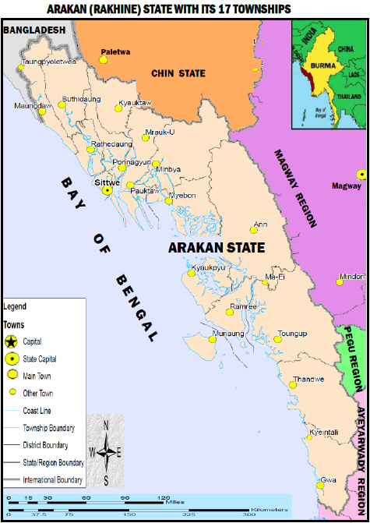
Figure 2: Burma’s State of Rakhine (Shown here as Arakan) (Dr. Bahar A. 2012. Racism to Rohingya in Burma)

of Islam. In addition, the Middle East achieved a monopoly on all trade originating from Eastern Asia, which allowed Muslim merchants to set up trade centers as far as China, thus allowing Islam to spread further. Muslim merchants began trading with Burma from their trading posts within Bengal during the ninth century, which led to a line of Muslim trading settlements within the Irrawaddy River valley (Moshe 1972). This is considered the first examples of Muslim settlement within Burma. The ancestors of the Rohingya first came into prominence during the fifteenth century. At the time, Arakan was an independent kingdom and its king, Narmeikhla, had recently failed in an attack on Burma and had been sent into exile in Bengal. While in exile, he entered the service of the Muslim Bengali sultan Jalaluddin Shah. Narmeikhla subsequently gained favor with the sultan and convinced him to support his attempt to reclaim his old kingdom. In 1430, Narmeikhla managed to restore his position as ruler of northern Arakan, but at the same time became a vassal of Bengal. As a result, he established the kingdom of Mrauk-U, which modeled itself after the Islamic governments of Bengal, despite its kings remaining Buddhist. The Bengalis who came with Narmeikhla went on to create their own settlements within the region, establishing a significant Muslim population within Mrauk U. The kingdom remained independent for many years until it was conquered by Burma in 1784 and incorporated into its territory.
After Burma conquered Arakan, the Muslim population of Arakan, two-thirds of the kingdom’s overall population, were expelled from Arakan and returned to Bengal (Balazzo 2015, 6-7). During the nineteenth century, when British colonial rule was predominant within the region of Bengal, the East India Trading Company stretched the boundaries of British India’s territory to encompass Arakan. This was done in an attempt to acquire farm labor, mainly for rice cultivation, by encouraging Muslim farmers within Bengal to move to Arakan for work in the fertile valleys of the region. In addition, the elimination of boundary restrictions further encouraged farmers to move to Arakan. It could be argued, however, that these waves of migration from Bengal had the most impact within Arakan due to its sparse population from the beginning in addition to the vast potential that the area held for promoting commerce. These patterns of migration did not cease after the initial wave, however, records of migration show that by the beginning of the twentieth century immigrants from India were still traveling to Burma in large numbers, usually more than 250,000 per year. Even with the opportunities brought on by these migrations, however, there was also a problem that developed from this and is continuing today: the internal conflict between the Rohingya and Rakhinese people who both occupy the Rakhine state.
Burma During WWII
The influx of migration due to Arakan becoming a province of British India did bring in more labor for agriculture, but it also significantly impacted the ethnic and religious patterns within the region, which led to various socio-economic problems. The Buddhist communities within the area increasingly resented the influx of Muslim farm workers settling in their land. Despite these resentments, however, relations between the two communities were relatively peaceful. Many researchers originally planned to study the relationship between these communities during the mid-1930s, but their efforts were cut short by the outbreak of World War II (WWII) and the Japanese invasion of Burma. The British were mainly concerned with the European theater of the war, so shortly after the Japanese advanced into Burma, the British withdrew their forces from the country. At first, there were no acts of violence between the Rohingyas and Arakanese. When the Japanese reached Arakan, however, Burmese nationalists, who saw the Japanese invasion as an opportunity to rid the country of its Indian migrants, joined them. They encouraged the Arakanese nationalists to join them, which lead to the first serious outbreaks of communal violence within Burma (Smith 1995). With weapons being provided to the Arakan population by the British to defend against Japanese invasion, multiple skirmishes and fatalities resulted among the Rohingyas and Arakanese. While the majority of the Muslim population remained loyal to the British, most Arakanese nationalists sided with the Japanese; however, when the British re-invaded Burma in 1945, the Arakanese nationalists turned against the Japanese. When the British attempted to regain their foothold within Southeast Asia during the final years of WWII, they formed volunteer force groups within Burma in order to aid the other Allied forces in expelling the Japanese from the region. Instead of combating the Japanese as intended, however, volunteers groups of both Arakanese and Rohingyas killed their deputy officers commissioned by the British to maintain order within northern Arakan and used their weapons to attack each others communities throughout northern Arakan. They committed many atrocities against the people present and destroyed many places of Buddhist and Muslim worship. The Secretary of British governor for Burma once wrote a record of and act of violence against an Arakanese community stating,
I have been told harrowing tales of cruelty and suffering inflicted on the Arakanese villages in the Ratheedaung area. Most of the villages on the West bank of the Mayu River have been burnt and destroyed by the Chittagonian V forces…. The enemy never came to these villages. They had the misfortune of being in the way of our advancing patrols. Hundreds of villagers are said to be hiding in the hills… It will be the Arakanese who will be ousted from their ancestral land and if they cannot be won over in time, then there can be no hope of their salvation (Chan 2005).

By the time WWII ended, the population distribution of Arakan involved most of the Rohingya population settling in the northern portion of the state while the majority of the Arakanese population settled in the south. This became a very distinct cultural boundary within Rakhine.

1948 to Present Day
After WWII, a Muslim mujahideen rebellion began not long after Burma had gained independence from Britain in 1948. Around this time, a political movement, called Tehrik-e-Pakistan, resulted in the creation of Pakistan from the Muslim-majority regions within British India. Inspired by this movement, the Muslim leaders within Rakhine sought permission from Pakistan to be annexed into East Pakistan (now the independent country of Bangladesh), however, the prime minister of Pakistan did not want to interfere with Burmese issues and turned down this proposal. After that idea failed, the Muslim community of Rakhine decided instead to establish an autonomous Muslim area in northern Rakhine in order to avoid discrimination from Buddhist officials and achieve self-determination (ICG 2014, 4). The mujahideen, however, had to compete with other ethnic and communist insurgencies that arose throughout Rakhine, such as a pair of communist insurgencies, labeled the Red Flag and White Flag, as well as multiple nationalist groups such as the Arakan People’s Liberation Party. At the height of the unrest, law and order within Rakhine became practically non-existent and government forces could maintain order in only a small portion of the state (ICG 2014, 4). Although the mujahideen rebellion ultimately failed, the government of Burma partially gave into their demands and established the Mayu Frontier Administration within northern Rakhine. This was done mostly in an attempt for the Prime Minister to gain votes from Rakhine’s Muslim population in exchange for the promise of autonomous region within northern Rakhine. The devolution of the Mayu Frontier, however, did not last long due to a 1962 military coup and the resulting Burmese government dissolving the Mayu Frontier Administration. The coup is speculated to have occurred due to the failing economy, regional insurgencies, social unrest, and corruption within the government at the time. The coup was led by a man named Ne Win, a politician and leader within the Burmese army, who instilled a new treatise into Burma’s proceedings, known as the Burmese Way to Socialism. The Burmese Way to Socialism served as both the ideology of the new socialist government and as an economic treatise that restricted foreign influence and increased the role of the military (Holmes 1967, 189). The mujahideen remained fairly active within Rakhine for a few more years, but their activities were severely halted after the Burma military’s coup d’état in 1962. In addition to severely limiting the activities of the mujahideen, though not altogether disbanding them, Burma’s military also banned alternate forms of political organization. This effectively ended Rohingya political activity, and led most people to acquire an even more negative view towards the minority groups living within the Rakhine state.
The military rule of Burma sought to live up to the ideals of the Burmese Way to Socialism. As a result, the next few years of politics within Burma were defined by xenophobia, isolation, and an immense fear of ethnic autonomy. Consequently, the Rohingyas were a primary target for the government’s new regulations. In 1977, a nationwide operation, dubbed Operation Nagamin (Dragon King), was launched to address illegal immigration throughout the country. During this time Rohingyas were put under considerable pressure from government officials conducting the operation, due to their lack of formal immigration status. The violent manner in which the operatives conducted their investigation caused approximately 200,000 Rohingyas to flee to Bangladesh in order to avoid the worst of the oppression. Pressure from the Bangladeshi government caused many of these refugees to return after only a year, but many still lacked immigration or citizenship papers, preventing their reintegration. In 1982, the Myanmar Citizenship Law was enacted and removed many legal rights that the Muslim population within Burma previously held. This new political vulnerability became apparent when the government deployed a significant military force into northern Rakhine in 1991. The military took advantage of the Rohingya’s lack of rights by confiscating their land for military camps. They also confiscated the Rohingyas’ crops as food for the army, levied various arbitrary taxes, and used the Rohingyas as forced labor. In the following years, many Rohingyas fled Rakhine to avoid the violence and injustice from the Burmese government, but no matter where they went, they often found themselves in poor conditions and without many basic rights. During this period, there were many attempts by both the Bangladeshi government and the UNHCR to repatriate these refugees back into Burma, but the inability of both organizations to reach an arrangement and the majority of refugees’ refusal to return to Burma made this difficult. Life for the Rohingyas who chose to remain in Burma did not improve at all. By 2001, disputes between Rakhine Buddhists and Muslims were becoming more and more frequent and often resulted in violence.
The combination of the Rohingya’s poverty and their exclusion from government procedures was the main cause for the stream of violent riots that erupted within Rakhine during 2012. The spark for this particular period of violence is most commonly accepted to be the rape and murder of a Rakhine Buddhist by a group of Rohingya men on May 28, which was shortly followed by the murder of ten Burmese Muslims on June 3. From that point, the violence once again escalated to an extreme level, with riot groups of Rohingyas burning the houses of Rakhine Buddhists and the Rakhine Buddhists answering this violence in kind. It escalated to the point that even civilians who claimed no stake in either side were being swept up in the conflict. In an attempt to restore order, the government of Burma declared a state of emergency and the military was deployed. Although they temporarily managed to settle the worst of the violence, it returned in its entirety during another wave of riots that began in October 2012. As a result of these two waves of violence, at least 190 people on both sides were killed and hundreds more were injured (ICG 2013, 7). The most significant damage these riots inflicted, however, was the displacement of thousands of people, mostly Rohingyas, from their homes who fled Burma to escape the violence. After the riots, tens of thousands of Rohingyas were forced into interment camp, some near the state capital, Sittwe, where there are not allowed to leave. Certain camps are located close to Sittwe, but both the Rohingya and Rakhinese are physically segregated from one another, creating a situation akin to the apartheid of South Africa (USHM 2015, 7).
Political Catalysts
Being one of the most ethnically diverse countries in Southeast Asia has made it difficult for the government of Burma to unite its people under a national identity. After Burma gained its independence in 1948, the ethnic minorities within the country came under pressure from the government, which sought to unite them under the “Burman” identity. This became the spark for multiple nationalist movements and insurgency groups that sought to maintain their ethnic identity; one of the first movements was that of the Karen National Union. Several other insurgent groups, such as the Shan State Army and the Kachin Independence Army, were formed shortly after and still operate today (Weightman 2011, 417). As stated in the historic summary, one of the main reasons for the status of Rohingya population in the past was the military coup d’état in the 1960s and the political changes brought on by the coup. Additionally, a new law passed in 1982 eroded the rights of the Muslim population, but how exactly did it do this? The simple answer is that it changed the definition of what it meant to be a citizen of Burma. The original definition of Burmese citizenship as stated by the 1948 Union Citizenship Act was:
Any person, inter alia, who: (i) was born of parents who belonged to any of the indigenous races of Myanmar; or (ii) was born within Myanmar and having at least one grandparent from any of the indigenous races; or (iii) was descended from persons who had made Myanmar their permanent home for two generations, and the person and their parents were all born in Myanmar; or (iv) was born within the territory of Myanmar after 4 January 1948 and one of whose parents was a citizen (ICG 2014, 10)

Adults were previously able to apply for proper citizenship if they had lived within Burma for at least five years and met certain other criteria. When the Myanmar Citizenship Law was put into action in 1982, however, the definition of a citizen changed significantly. The law introduced three kinds of citizens: citizens, associate citizens, and naturalized citizens, each of which came with different degrees of entitlement. Although the law shared similarities to the 1948 act in that it allowed citizenship for any children born to any recognized indigenous group within Burma, it also limited the number of recognized ethnic groups to 135. These 135 recognized groups are further categorized into eight national races determined by the regions they live in. For example the Shan represent 33 ethnic groups who speak a number of different languages (Weightman 2011, 412). Only one Muslim community in Rakhine, the Kaman, is a recognized indigenous group within Burma while others, such as the Rohingya, have had to make due with the provisions given through descent, associate, or naturalized citizenship.
Another reason that many of the newer generations of Rohingya have experienced a lack of citizenship rights is due to them being unable to acquire physical documentation of identity. After 1951, any Burmese citizen over the age of 12 was encouraged to register for national registration cards (NRCs). Seven years after the implementation of the Myanmar Citizenship Law, there was an inspection to check the status of everyone to see what his or her citizenship status was under the new law. Those who met the requirements had their NRCs replaced with citizenship scrutiny cards (CSCs). In a manner that showed no accordance to the law, however, the majority of the Rohingya population who surrendered their NRCs did not receive CSCs in exchange. Instead, the majority of the Rohingya population was presented with temporary registration certificates (TRCs), which do provide for certain limited rights, but for the most part are not seen as proof of citizenship. In addition, the government of Burma has yet to give the Rohingya a definite legal label. Burma’s government refuses to refer to the Rohingya population as a stateless nation, but has on occasion referred to them as “Myanmar citizens,” though not in a way meant as a legal status. This does not hold much significance, however, as government officials have recently labeled the Rohingya as “Bengalis” and now consider them “illegal immigrants from Bangladesh” (Lewa 2009, 12). This has created multiple complications both for how outside people define the Rohingya as well as the Rohingya themselves.
The Rohingya population, as a result of not being able to acquire proper citizenship status, faces discrimination. For example, Rohingyas who wish to wed must obtain permission from the authorities and are sometimes limited in the number of offspring they are allowed to have. Sometimes the only way to be granted permission to marry is through expensive bribes for government officials, which may take up to several years to accumulate (Lewa 2009). A 2014 survey done by Transparency International, an organization that combats corruption, ranked Burma’s government as the twenty-first most corrupt country in the world (Transparency International 2015). Another example is that, after 1994, children born to Rohingya parents were no longer issued birth certificates. In addition, the Rohingyas who only have TRCs are extremely limited in their ability to move outside of their own township, which severely limits employment options and access to government services. Being non-citizens also makes it impossible for any Rohingya to be employed in any areas of health and education within Burma. Consequently, Burmese staff, who operate clinics and schools within Rakhine, cannot communicate well with the Rohingya patients and often treat them with contempt. There have also been multiple attempts by certain political parties, such as the Arakan National Party, to approve a bill that would terminate the ability of TRC holders to vote. Such a move is potentially incendiary because many Rohingyas see the ability to vote as their last hope to rise higher as a citizen. In a more recent attempt to address the citizenship issues of the ethnic groups within Rakhine, including the Rohingya, a plan was developed after the review of a report on the 2012 Rakhine riots. Dubbed the “Rakhine State Action Plan,” part of its layout is to address the citizenship issue by making those without full citizenship “naturalized citizens” under the definition of the 1982 Citizenship Law (ICG 2014, 32-33). Rohingya leaders consider this problematic due to the fact that naturalized citizens still retain far less rights than full citizens and that it is easier for the government to revoke naturalized citizenship than full citizenship. Many worry that if they accept this deal, the government will take away any citizenship they have left. Therefore Rohingya leaders have established that they will only accept being given full citizenship (ICG 2014, 31-33).
Social and Cultural Catalysts
Ever since the influx of Muslim migrants from India moved into Rakhine, they have been subject to many bouts of ‘eye for an eye’ violence with the Rakhinese. Most people outside Burma believe that different religious views are the main catalyst for violence between Rohingyas and Rakhinese. Religion, however, has statistically been a less potent catalyst for the violence between them. Most outbursts of violence have been attributed to ethnic, political, and social reasons. Despite this, however, certain leaders within the Buddhist faith have contributed significantly to violence against the Rohingya. Some Buddhist monks have led nationalist movements where they deliver hate speeches against the Rohingya, which are typically not countered, and even supported, by government officials (USHMM 2015, 9). One of the most extreme examples of this is the 969 movement which is a nationalist movement primarily headed by Buddhist monks. This movement achieved its peak influence following the waves of violence that took place within the state of Rakhine in 2012 (ICG 2013, i). The main ideas spread through the movement were those of Islamophobia, and the idea that the Rohingya were terrorizing the ethnic Rakhines. This idea was already present within Rakhine ever since the first ancestors of the Rohingya settled in Rakhine, as most of the native population felt that they were taking away their jobs and their land.
As a result of the Burmese government not recognizing the Rohingya population as citizens, other people have found that this makes it easy to use the Rohingya in ways that one would not consider treating a fellow citizen. Examples include forcing Rohingyas to perform intense and dangerous labor, random and unreasonable taxation, and seizing their land without payment or warning. This is a very detrimental situation for both the Rohingya and the Rakhinese. The Rohingyas are the ones suffering without rights, but the Rakhinese are being taught to dehumanize the Rohingya. At first, the reason for these acts against the Rohingya was merely due to the fact that it was a convenient way to gain money, land, and free labor, but the mindset that went into these actions was what is dangerous. The Rakhinese are treating the Rohingya in ways they would probably not treat a fellow Rakhinese. Therefore, even if it is not immediate, even if it only truly manifests generations later, the Rakhinese are starting to not see the Rohingya as people. It is here that the danger truly lies, because once a person starts to dehumanize someone else, they feel that they can do whatever they want with them. It may become even worse and evolve into a fear of something inhuman that is different from them. This is especially apparent in the results from hate speeches given by Buddhist nationalists. These speeches are often given by influential religious figures, so their speech carries considerable influence to the citizens living in Rakhine (USHMM 2015, 9). The fact that the Rohingya have returned and even incited violence of their own against the Rakhinese, especially during the 2012 riots, only serves to cement this belief and continue the cycle of violence.
Rohingyas Outside of Burma
While life is hard for the Rohingya within Burma, it is hardly an ideal situation for those who are in other countries. Although migration is often viewed with economic value in mind in Southeast Asia, it can also been seen as a threat to internal ethnicity, culture and national identity; as stated by Castles et al., “Immigration is seen as a threat to the nation-state and should therefore only be temporary.” (Castles et al. 2014, 156). As stated above, many Rohingya fled to Bangladesh in the past in order to escape violence inflicted by the Burmese military. Currently approximately 20,000 Rohingyas are living in the refugee camps in Bangladesh where they are offered limited protection and assistance by the UNHCR. The majority of the Rohingya population in Bangladesh lives outside these camps, however, and is viewed as illegal migrants by the Bangladesh government. One article (Ragland 1994, 301) described the living arrangements for Rohingya refugees within Bangladesh as such:
Conditions in the camps have steadily worsened: as more refugees have arrived, the Bangladeshi government has withheld food rations, slowed the construction of shelter, and imposed other restrictive measures to compel the refugees to return to Burma. Many refugees have even been beaten, raped, and robbed by local police. In addition, the Rohingyas-particularly the children-suffer increasingly from a high death rate, a variety of health problems, and widespread malnutrition. Since December 1991, more than two thousand refugees have died in the camps.

As of 2015, many Rohingya people have been attempting to flee from violence in Burma, often via boats, in order to reach other Southeast Asian countries such as Thailand and Malaysia (see Figure 3). Because many of these boats are in poor condition, the sheer amount of people packed into a boat at a time makes these journeys fatal for many of migrants, either through exposure, lack of sustenance, or boats sinking due to storms or high winds. Another complication is the immigration restrictions of the other countries that many of these refugees face during these forced migrations. On the one hand, many countries within Asia look at migration mainly in
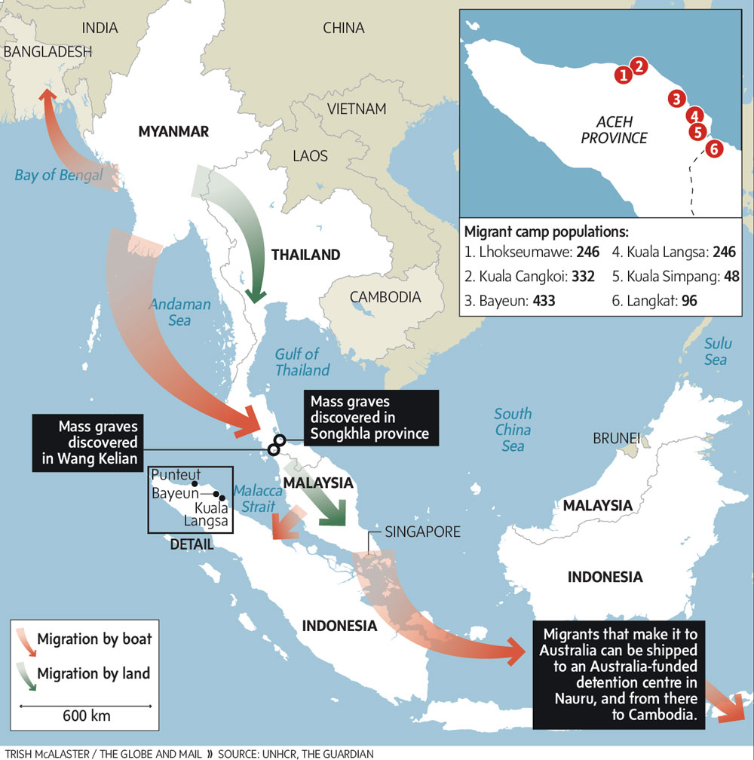
Figure 3: Map of Rohingya migration (Vanderklippe. 2015. In transit to nowhere: Rohingya move from one bleak horizon to another).

economic terms. Receiving countries see the potential profit in temporary labor, while the sending countries see the potential benefits of remittance. This, however, is more applicable to legal migration, and the majority of Rohingya migrations are illegal migrations to escape violence. As such, the Rohingya who make these migrations are not offered protection in the countries they land in. Thailand sees the Rohingya as a threat to their national security. Some even fear that the Rohingya may join militant Islamic insurgent groups, such as the Jemma Islamiyah, in southern Thailand. Thailand has been known to unofficially deport Rohingya refugees to areas controlled by insurgent groups along the Burma-Thailand border. Due to these insurgent groups having connections with illegal activities, the Rohinyga who cannot afford to be smuggled back into Burma or Thailand are given to human traffickers who then sell them as slave labor for fishing boats and plantations. Some people who have reached Thailand recount being confined to overcrowded camps near the Thailand-Malaysia border, where smugglers held them for ransom. They speak of daily beatings, people dying and being unable to move anywhere outside of confinement (UNHCR 2014). In 2008, there were three suspected incidents of Rohingya boat people being sent to Ko Sai Daeng, an island off the coast of Thailand in the Andaman Sea. They would be held there for a time by the Thai military before being towed back out into the sea and then cast adrift on tiny boats with little food and water (Lewa 2009, 13). Malaysia is the location most boat people attempt to travel to, because there are thriving Rohingya communities among the Burmese populations in the cities of Kuala Lumpur and Penang. Despite this, refugees still run the risk of being arbitrarily arrested and intimidated by the Malaysian police and paramilitary volunteer corps in charge of determining the legitimacy of immigrants. Illegal migrants are usually deported over the border into Thailand where they are again at the mercy of smuggling brokers (Lewa 2009, 13; HRW 2009, 8).
Conclusion
In more recent years, the Rohingya have gained prominent international attention. The United States House Committee on Foreign Affairs (USHCFA) released a simple resolution in 2014 that stated its disagreement with Burma on their treatment of the Rohingya and to pressure them to end said treatment (USHCFA 2014). The USHMM has hosted panels where experts explain the Rohingya situation and show pictures that capture their suffering on its exterior walls. Refugee and humanitarian groups such as the UNHCR and Médecins san Frontières regularly try to provide aid to the Rohingya people both inside and outside of Burma. Despite gaining more attention in other countries throughout the world, the Rohingya continue to be one of the most marginalized ethnic groups today. Although many people have systematically attempted to deny rights to the Rohingya population, they have also inadvertently created a stronger sense of union and identity for many of the Muslim communities living within Rakhine. Before the 2012 riots, many Muslim communities refused to identify themselves specifically as “Rohingya.” After they saw how the riots affected their communities regardless of their identity, however, they realized that they needed to have a stronger political identity if they were going to be able to face the current threats against them. Many Muslims feel that, they had everything stolen from them after the 2012 riots, and, as a result, they realized that they needed to retain a uniting identity. Many leaders within the Muslim community are now pushing to become universally recognized as “Rohingya” so that they can push for recognition and hopefully one-day gain an identity within Burma. With its citizens recently voting more and more in favor of democracy within Burma, the future of the Rohingyas may change for the better.

References
Balazzo P. 2015. Truth & Rights: Statelessness, Human Rights, and the Rohingya. Undercurrent 11 (1): 6-15.

Castles S., Haas D. H., Miller J. M. 2014. The Age of Migration: International Population Movements in the Modern World. New York, U.S.A: The Guilford Press

Central Intelligence Agency. Burma, The World Factbook, https://www.cia.gov/library/publications/the-world-factbook/geos/bm.html (last accessed 11 April 2016)

Chan A. 2005. The Development of a Muslim Enclave in Arakan (Rakhine) State of Burma (Myanmar). SOAS Bulletin of Burma Research 3 (2): 396-420.

Charney M. W. 2005. Theories and Historiography of the Religious Basis of Ethnonyms in Rakhaing (Arakan), Myanmar (Burma). Paper presented at the Workshop “The Forgotten Kingdom of Arakan: A Public Seminar on the People of Present Day Arakan State of Myanmar.”

Holmes A. R. 1967. Burmese Domestic Policy: The Politics of Burmanization. Asian Survey 7 (3): 188-197.

Human Rights Watch (HRW). 2009. Perilous Plight: Burma’s Rohingya Take to the Seas, https://www.hrw.org/sites/default/files/reports/burma0509_brochure_web.pdf (last accessed 15 April 2016)

International Crisis Group (ICG). 2014. Myanmar: The Politics of the Rakhine State. Asia Report N°261

International Crisis Group (ICG). 2013. The Dark Side of Transition: Violence Against Muslims in Myanmar. Asia Report N°251

Lewa C. 2009. North Arakan: an open prison for the Rohingya in Burma. Full Migration Review 32: 11-13.

Moshe Y. 1972. The Muslims of Burma: A Study of a Minority Group. Heidelberg, Germany: Heidelberg University.

Ragland K. T. 1994. Burma’s Rohingyas in Crisis: Protection of “Humanitarian” Refugees under International Law. Boston College Third World Law Journal 14 (2): 301-336.

Smith M. 1995. The Muslim Rohingya of Burma. Paper presented at Conference of Burma Centrum Nederland.

Transparency International. 2015. Corruption Perceptions Index 2014: Results. https://www.transparency.org/cpi2014/results (last accessed 24 April 2016)

United Nations High Commissioner for Refugees (UNHCR). 2014. As thousands continue to flee Myanmar, UNHCR concerned about growing reports of abuse. http://www.unhcr.org/5396ee3b9.html (last accessed 18 April 2016)

United States Holocaust Memorial Museum (USHMM). 2015. “They Want Us All To Go Away: Early Warning Signs of Genocide in Burma. https://www.ushmm.org/m/pdfs/20150505-Burma-Report.pdf (last accessed 20 April 2016)

United States House Committee on Foreign Affairs (USHCFA). 2014. “H.Res.418- Urging the Government of Burma to end the persecution of the Rohingya people and respect internationally recognized human rights for all ethnic and religious minority groups within Burma.”

Weightman A. B. 2011. Dragons and Tigers: A Geography of South, East and Southeast Asia. Hoboken, NJ: John Wiley & Sons Inc.

